Installation Guide
SecretManager v0.1-x

Summary : | This guide explains how an administrator can install « SecretManager » tool.  Note: I'm sorry in advance by all the English mistakes you find in this document.

DOCUMENT HISTORY
Version | Date | Modifications
0.1-0 | 07/02/13 | Creation
REFERENCES
Index | Title | Reference

TABLE OF CONTENTS
1. Avant Propos 4
2. Mise en garde 4
3. Pré-requis 4
3.1. Installation minimum d’Apache 4
3.2. Installation minimum de PHP 4
3.3. Installation de phpMyAdmin 4
4. Packaging de l’outil 5
5. Etapes d’installation 5
5.1. Etape 1 5
5.2. Etape 2 5
5.3. Etape 3 5
5.4. Etape 4 5
6. Première connexion à l’outil « SecretManager » 9
7. Erreurs de connexion à l’outil « SecretManager » 10
7.1. Erreurs de connexion à la base de données 10

Foreword
The tool "SecretManager" is an application written in PHP 5 and is based on a default MySQL database.
This document does not describe how to install the software infrastructure such as:
- Apache ;
- PHP 5 ;
- MySQL ;
- SSL.
For this please refer to the installation documentation for these programs.

Caution
Attention, despite the attention paid to this tool, you use this tool at your own risk.
Although this version is a "beta", you can begin to use this product in production.
The file must be protected and which should be accessible by the user "root" user or application owner "SecretManager".

Prerequisites
As seen above, the tool "SecretManager" is an application written in "PHP 5". "SecretManager" force dialogue "HTTPS", therefore, you must install "OpenSSL" and use the certificate as appropriate and in accordance with your Company constraint.

Minimum Apache installation
Apache version that was used during development was the release:
Apache/2.2.14 (Unix) DAV/2 mod_ssl/2.2.14 OpenSSL/0.9.8l PHP/5.3.1

Minimum PHP installation
PHP version that was used during development was version "5.3.1".
PHP must be compiled with the following modules (minimum):
Module | Version / Extension
Hash | sha1
Mcrypt | 2.5.8 width rijndael-256
PDO | pdo_mysql 5.1.44
OpenSSL 0.9.8l 5 Nov 2009
Session

PhpMyAdmin installation
The version of "phpMyAdmin" which was used during development was the version "3.5.2.2".

Tool Packaging
The tool "SecretManager" is provided as an archive.
To distinguish one from another archive, the latter will have the version number in their name.
Thus, this archive is called:
SecretManager-v0.1-6.zip

installation STEPS

Step 1
You must copy the archive in the "DocumentRoot" stated in the "httpd.conf" of your Apache server.

Step 2
You must unzip the archive has been copied (see 5.1). Decompression is dependent on the operating system of your server. The deliverable is a "zip" file, use the appropriate utility.

Step 3
The archive, unpack once, must produce the directories and sub-directories:
Directory | Sub-directory
SecretManager
 | Documentations
 | Installation
 | Libraries
 |  | Labels
 |  | Radius
 | Pictures

Step 4
Tool to connect to the "phpMyAdmin" as "root" database "MySQL".
In the home page "phpMyAdmin", pass the theme to "pmahomme."
You should get the screen below:

Dans cette interface, il faut utiliser l’onglet « Importer ». En cliquant sur cet onglet, vous arriverez dans l’écran ci-dessous :
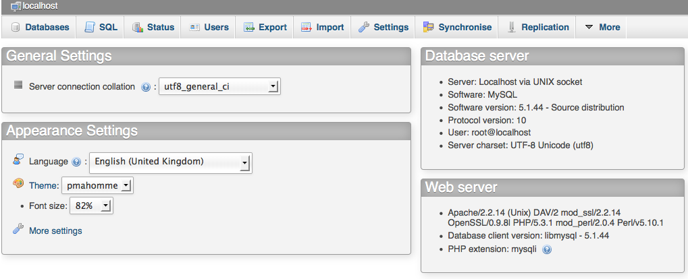
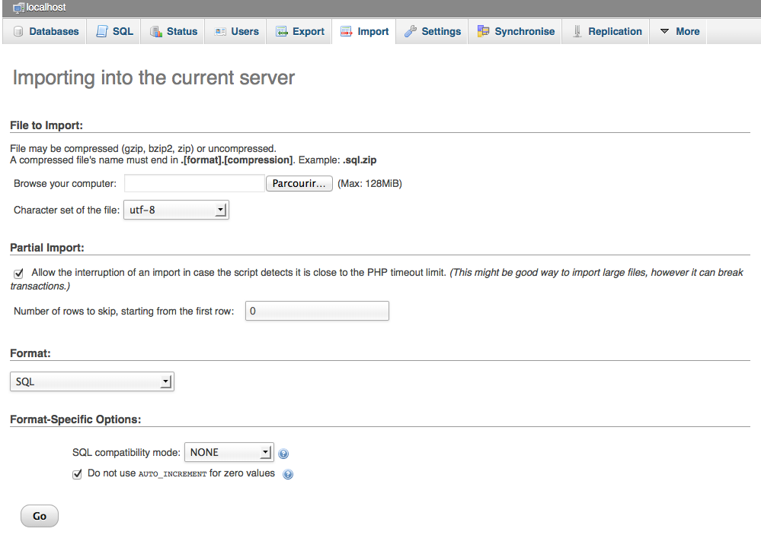
It is important to keep the "Character set of the file" to "utf-8".
Then you have to click on the "Browse ...". This action brings up a window in which you must specify the SQL to execute.
SQL files are in the directory "Installation" in "SecretManager".
These files are:
Name | Designation
Secret_Manager-0.sql | This file created SQL database "Secret_Manager" and all its tables.  Warning: This script deletes the database if it already existed. You will lose all data if the latter possessed.
Secret_Manager-1.sql | This SQL file created user "iica_user." This user is the tool that allows the "SecretManager" to access the database "Secret_Manager." It is the user of the database.
Secret_Manager-2.sql | Warning: you must first select the database "Secret_Manager" before running this script.  This inserts the SQL file data, such as data of the reference tables. It also creates the default user of the tool "SecretManager".
After running the SQL script "Secret_Manager-0.sql", you should get the following result in "phpMyAdmin":
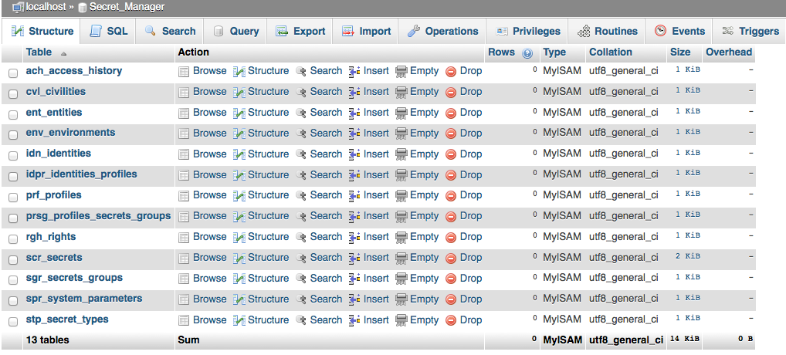
However, after running the SQL script "Secret_Manager-2.sql", you should get the following result in "phpMyAdmin":
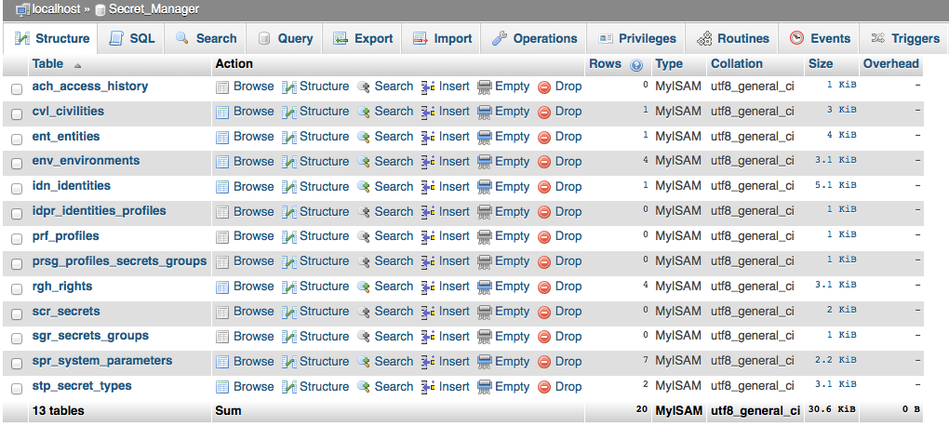
Normally, you should be able to use the tool "SecretManager".

First connection to the tool « SecretManager »
Start with a local connection to your server. To do this, use your browser type:
http://localhost/SecretManager/
You should get the screen below:
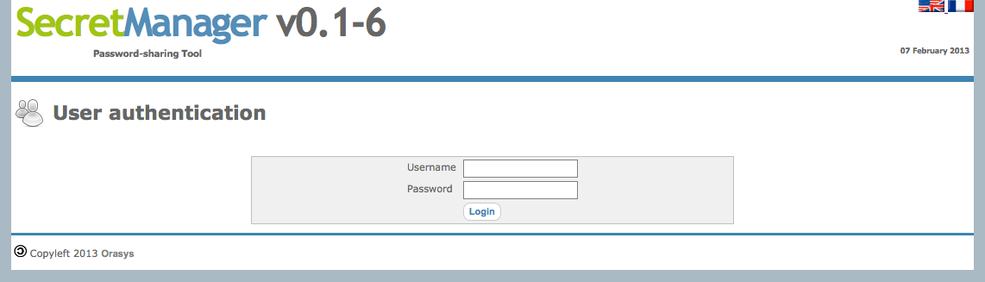
As the tool has been installed, the default user is "root" and the default password is "Welcome !" (Space is important between 'e' and '!').
Warning: We recommend that you change this password before moving the tool "SecretManager" to "Production".
You should get the screen below:
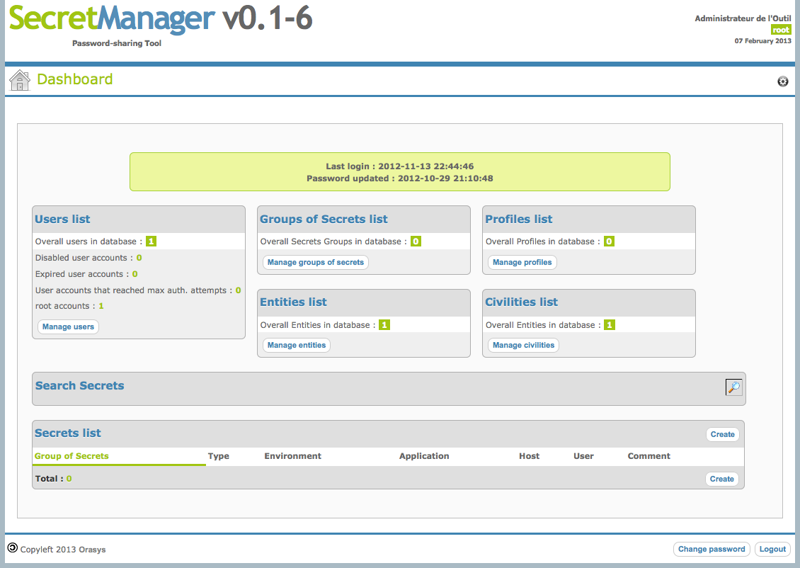
If this is the case, your installation is complete and you can start playing the "Administration Guide".

Connection errors « SecretManager » tool
Errors may be many, but here are some ways of prospecting:

Connection errors database
Environment variables that manage access to the database are in the file "Config_Access_DB.inc.php" in the subdirectory "Libraries" installation directory "SecretManager."
The password for user "iica_user" should for example be in phase with the database.

